Question 2
In a nation with K being abundant and L being scarce, with opening of trade the equilibrium rental rate rises by a greater percentage than the percentage changes in the prices of both goods, while the equilibrium wage rate rises by less than the percentage changes in the prices of both goods.” Discuss the theory behind this statement.
The theory behind this is the H-O theorem which incorporates a number of realistic characteristics of factors of production that are left out of the simple Ricardian model. The H-O model assumes private ownership of capital. Use of capital in production will generate income for the owner. We will refer to that income as capital “rents.” Thus, whereas the worker earns “wages” for his or her efforts in production, the capital owner earns rents. Even though the equilibrium rate raises by less than the price change for good and services, this theory assumes that any increase in a factor of production increase the prices of the resultant goods and services. In this case, of a 2-factor, 2 good Heckscher-Ohlin model, an influx of workers from across the border would shift the production possibility curve outward and decrease the production of the capital-intensive product.
Question 3
Define the concept of import-biased growth.
Import biased growth is a growth that expands a country’s production possibilities disproportionately in that country’s import sector.
(b) Then with the help of a diagram (with PPF and Indifference curves) discuss the impact of this type of growth on the wellbeing of the nation.
The impact of this type of trade is that it allows us to separate consumption and production points. A countryís terms of trade are defined as: TOT = Pexport/Pimport = Pe/Pi If your TOT rise (i.e., Pe rises or Pi falls), welfare rises. (i.e., you are better off). Below, the country exports cloth. If P cloth rises, what happens? (1) The production of cloth rises (2) The country’s terms of trade improves (3) Welfare increased; the country is now on a higher indifference curve. But trade could also lead to declining terms of trade (i.e., Pcloth falls relative to Pfood). Generally, any event that increases export prices Will improve your terms of trade, and anything that raises import prices hurts your terms of trade.
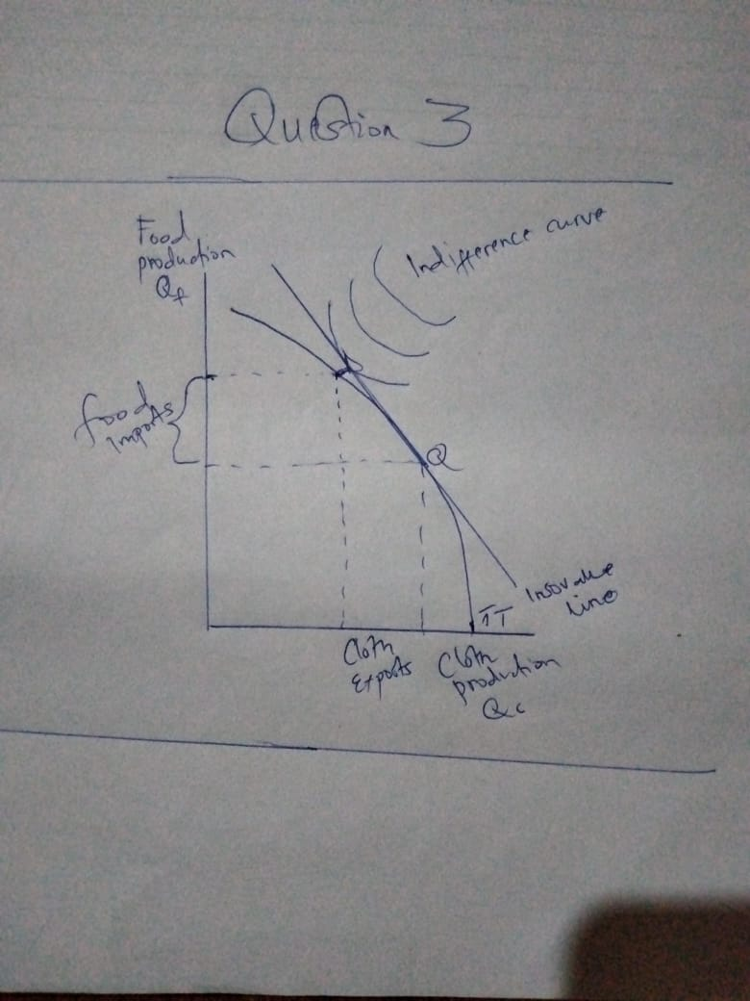

(c) Does your answer to part (b) depends on whether the growing economy is small or large? Discuss fully.
Yes, a growing economy increases the welfare of a country therefore it depends if the economy is large. In a large economy, the GDP is rising, and the economy is in solid shape, and the nation is moving forward. On the other hand, if gross domestic product is falling, the economy might be in trouble, and the nation is losing ground.
Question 5
Suppose when Indonesia opens to trade, it imports airplanes, a capital-intensive good from the rest of the world (ROW).

(a)According to the Heckscher-Ohlin theorem, is Indonesia capital-abundant or labor-abundant? Briefly explain.
Indonesia is a is labor abundant because its relative endowment of labor is large compared to other countries. It has enough supply of labor compared to other countries and that’s why they import more airplanes.

(b) Assuming that consumers tastes are the same in all countries draw a diagram to illustrate the pre- trade equilibria for Indonesia and the (ROW.
(c) In your diagram show the post- trade equilibrium points for each of the two countries including the production points, consumption points, the international price, and the trade triangles.
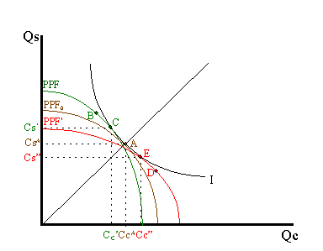
Explanation
The difference in resource endowments is sufficient to generate different PPFs in Indonesia and other countries such that equilibrium price ratios would differ in autarky. To see why, imagine first that Indonesia and other countries are identical in every respect. This means they would have the same PPF (depicted as the brown PPF0 in the adjoining figure), the same set of aggregate indifference curves and the same autarky equilibrium. Given the assumption about aggregate preferences, that is U = CCCS, the indifference curve, I, will intersect the countrys' PPFs at point A, where the absolute value of the slope of the tangent line (not drawn), (PC/PS), is equal to the slope of the ray from the origin through point A. The slope is given by CSA/CCA. This shows that Indonesia will have more labor and less capital than initially. This implies that K/L> K*/L*, or that other countries is capital-abundant and Indonesia is labor-abundant.
Indonesia experiences an increase in L and a decrease in K. These changes will cause an increase in output of the labor-intensive good (i.e., piloting) and a decrease in output of the capital-intensive good (airplanes). If price were to remain constant, production would shift from point A to D in the diagram and the Indonesia PPF would shift from the brown PPF0 to the red PPF*.

